

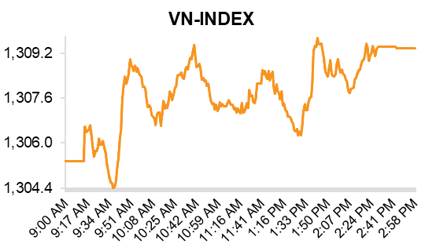

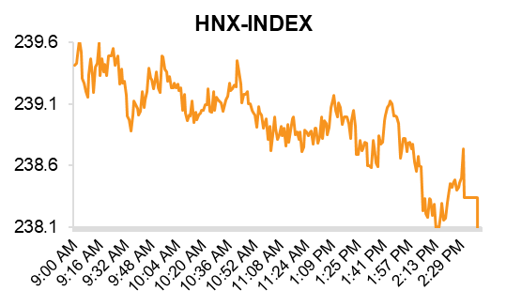

|  |
| --- |
|  |
| Commentator(s): |
| ​​ |
| **Hinh Dinh – Head of Strategic** |
|  |
| [Barry.weisblatt@vndirect.com.vn](C:\\Users\\barry.weisblatt\\Downloads\\Barry.weisblatt@vndirect.com.vn) |

|  |
| --- |
| Market Commentary |

**Stocks edged; led by financials**

The VN-Index opened higher on Monday and traded in the green for most of the session. The index closed up 0.3% at 1,309.4 points, successfully holding above the key level 1,300, with improved liquidity. Total trading value rose 13% to VND21.1tn (USD824.5mn). In contrast, the HNX-Index declined 0.4% to 238.3.

Most sectors advanced today, with notable gains led by Financial Services (+1.2%), Real Estate (+1.2%), and Telecommunications (+1.9%). In contrast, Industrial Goods & Services (-0.5%), Chemicals (-0.2%), Construction & Materials (-0.2%), and Banks (-0.1%) edged lower.

BCG (-6.9%) hit its floor price today following news that a senior executive had been arrested. Specifically, on March 1, 2025, Bamboo Capital announced that on February 28, 2025, the company was notified by the authorities that they plan to press charges against Mr. Nguyễn Hồ Nam, the group’s founder. This negative development also weighed on certain banking stocks, including CTG (-0.6%) and TPB (-3.0%), as these banks reportedly have significant outstanding loans to BCG. In addition, ORS (-6.7%) also hit its floor price, as the company had previously served as the advisor for BCG and its subsidiaries’ bond issuances. However, data on the specific volume of BCG bonds currently held by ORS is unavailable.

The Financial Services sector (+1.2%) posted solid gains today, led by VCI (+2.3%), FTS (+4.9%), VIX (+3.1%), and BSI (+3.0%), following new directives from the Prime Minister. Specifically, Prime Minister Pham Minh Chinh has signed a directive outlining key tasks and breakthrough solutions to accelerate economic growth and expedite public investment disbursement, aiming to achieve a national GDP growth target of at least 8% in 2025. The Prime Minister also emphasized that commercial banks are strictly prohibited from freely raising interest rates outside of policy guidance, engaging in unfair competition, or creating an uneven playing field. These policy directions are expected to create a low interest rate environment, which could shift capital flows away from traditional savings deposits into higher-risk assets such as equities. This trend would directly benefit securities companies, as increased trading activity and rising demand for margin lending would help drive their revenue growth.

Foreign investors net sold today, with net selling value of VND383.1bn (USD15.0mn). Selling momentum focused on TPB (VND262.6bn, USD10.3mn), TNH (VND127.4bn, USD5.0mn), FPT (VND73.0bn, USD2.9mn) and HAH (VND52.1bn, USD2.0m). On the contrary, they bought VHM (VND129.4bn, USD5.1mn), VCI (VND82.3bn, USD3.2mn) and GEX (VND54.6bn, USD2.1mn).

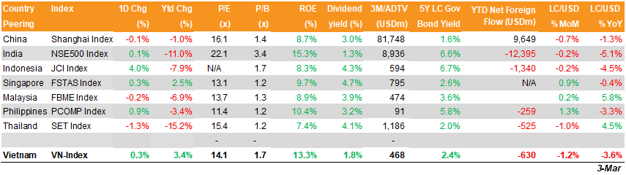Today’s top gainers included VHM (+3.3%), VIC (+2.1%) and VNM (+1.6%), while top laggards included CTG (-0.6%), TPB (-3.0%) and GVR (-0.9%).

**Macro Note**

**Manufacturing PMI remains in contractionary territory in February**

In February, the S&P Global Vietnam Manufacturing PMI came in at 49.2, signaling a continued contraction in the manufacturing sector for a third consecutive month, albeit a marginal improvement from January's 48.9.

New orders experienced a further decline, accelerating to the fastest rate of contraction since September of the prior year, reflecting persistent demand weakness across both domestic and international markets. Export demand remained subdued, evidenced by a significant reduction in new foreign orders for a fourth consecutive month.

Correspondingly, manufacturing output contracted for a second successive month. In response to the reduced order flow, firms curtailed workforce replacement, resulting in a fifth consecutive month of employment decline, though the rate of job cuts moderated slightly from January.

Contrasting the broader sector trends, purchasing activity witnessed a modest increase in February. This uptick, in part, reflected growing business confidence regarding future output projections, which reached a nine-month high. In addition, business confidence strengthened for the second consecutive month, reaching its highest point since June 2024. Overall, despite persistent stagnation in headline PMI figures, emerging indicators such as increased purchasing activity and a deceleration in job cuts suggest a cautiously optimistic outlook.

Initiation Reports

**VSC - Underperforming M&A project weighs on prospects – HOLD**

|  |  |  |  |
| --- | --- | --- | --- |
|  | | | |
| Current Price | | VND18,600 | |
| 52Wk High/Low | VND22,046/15,500 | | |
| Target Price | | VND19,000 | |
| Previous TP | | NA | |
| TP vs Consensus | | NA | |
| Upside | | 7.5% | |
| Dividend Yield | | 2.7% | |
| Total stock return | | 10.2% | |
|  | |  | |
| Growth rating | Neutral | | |
| Value rating | Neutral | | |
| ST Technical Analysis | | [Neutral](https://dstock.vndirect.com.vn/tong-quan/QNS/goc-nhin-ky-thuat-popup?defaultType=cipShort) | |
|  | |  | |
| Market Cap | | USD208.8mn | |
| 3m Avg daily value | | USD2.1mn | |
| Avail Foreign Room | | USD94.1mn | |
| Outstanding Shares | | 286.8mn | |
| Fully diluted O/S (*) | | 301.1mn | |
| |  |  |  |  | | --- | --- | --- | --- | |  | VSC | Peers | VNI | | P/E TTM | 11.6x | 15.8x | 13.9x | | P/B Current | 1.1x | 2.1x | 1.7x | | ROA | 11.0% | 11.0% | 2.1% | | ROE | 12.3% | 15.2% | 12.3% |   *as of 2/26/2025 | | | |
| (*) After the ESOP issuance | | | |
| Share Price performance | | | |
|  | | | |
|  | | | |
| |  |  |  |  | | --- | --- | --- | --- | |  | | | | | **Share price (%)** | **1M** | **3M** | **12M** | | Ordinary share | ​-3.0 | ​-0.5 | ​11.0 | | Relative to index | ​-0.1 | ​-0.1 | ​6.9 | | | | |
|  | | | |
| Ownership | | | |
| Vietinbank Fund Management Company Limited | | | 16.1% |
| Others | | | 83.9% |
| Business Description | | | |  |
| VSC is a port operator in Hai Phong port cluster. Its two ports collaborate with Evergreen and operate at high utilization. In 2024, VSC invested in Nam Hai Dinh Vu (NHDV) to expand its total capacity, increasing it by 500,000 TEUs. | | | |  |
|  | | | |  |
|  | | | |  |

* We issue a HOLD rating with 7.5% upside and a 2.7% dividend yield.
* VSC is a port operator in the Hai Phong port cluster. Its two ports collaborate with Evergreen and operate at a high utilization rate. In 2024, VSC invested in Nam Hai Dinh Vu (NHDV) to expand its total capacity by 500,000 TEUs.
* TTM P/B of 1.13x is lower than domestic and regional port operators, implying low growth prospects for VSC in line with our revenue forecasts.

**Financial Highlights**

* VSC’s revenue in 2020-2024 recorded a CAGR of 10.5%, mainly driven by VGR and GR’s stable container throughput of port operations.
* Our base case indicates that currrent projects will operate stably, while an M&A project will see a slight gain, driving net revenue to rise 3.3%/3.8% YoY in 2025-26.
* We forecast EPS to rise 17.9%/12.4% in FY26/27, driven by stronger associate profits, higher financial income from retained cash, and lower interest costs as bank loans are paid down.

**Investment Thesis**

**Long-term contracts support continuing high port utilization rates**

VSC operates two major port terminals in Hai Phong, Vip Green Port (VGR) and Green Port (GP), in collaboration with Evergreen Shipping Line. Over the past several years, these ports have consistently run at near-full capacity, averaging a utilization rate of 101.6% from 2018 to 2024. We expect these high utilization rates to continue over the next two years, mainly thanks to long-term contracts signed with Evergreen Shipping Line, and stable trade on intra-Asia routes. This will secure VSC’s operations above the FY24A base in the upcoming years.

**NHDV acquisition unlocks long-term growth potential**

In 2H24, VSC completed its acquisition of Nam Hai Dinh Vu (NHDV), increasing total capacity by 45% to 1.6 million TEUs within the Hai Phong port cluster. This move strengthens VSC’s presence along the Cam River network, offering opportunities to streamline cargo flows and enhance efficiency. In the long term, we expect that NHDV could also play a role in VSC’s strategic realignment, potentially absorbing volumes from Green Port as its location becomes less competitive amid ongoing regulatory shifts in Hai Phong’s inner port cluster.

**However, the timing is not yet optimal**

We initiate coverage with a HOLD, as we believe VSC has yet to reach its optimal entry point. Following the sale of NHDV to VSC, Gemadept redirected cargo and clients to Nam Dinh Vu, leaving VSC with the challenge of filling NHDV’s capacity. We take a conservative stance, factoring in just one additional service per year in 2025-26 due to increased capacity at Hai Phong and intensifying competition as Gemadept tries to attract more intra-Asia vessels to its ports after losing MSC’s service at NDV to HTIT.

**Given our low utilization rate expectation at NHDV, our TP implies a 1.13x P/B**

The current P/B of 1.1x trails domestic peers (2.1x) and the regional average (2.2x). With FY25F ROE at 6.0%, we believe this valuation is quite fair, reflecting challenges from NHDV’s low utilization.

Read the full report : [HERE](https://nhanha-public-api.vndirect.com.vn/click/OGE1MjkxZDI5MjY4MjM5MjAxOTI2YjVhNDMwNjQ5N2U=/MzlmYmYzMzcwNmIxNGI1MjkzMDg1M2QwODBjZmY5ZWE=/39fbf33706b14b52930853d080cff9ea-VSC_Initiation_20250303.pdf/cmVzZWFyY2hAdm5kaXJlY3QuY29tLnZu/NTgyMTE=)

|  |
| --- |
|  |
| Analyst(s): |
| ​​ |
| Hoang Dang |
| hoang.danghuy2@vndirect.com.vn |

**Real Estate (+1.5%), Energy (+0.8%), and Consumer Staples (+0.7%) rose, while Health Care (-0.4%) and Materials (-0.1%) lost ground today.** Top index movers included VHM (+3.3%), VIC (+2.1%), VNM (+1.6%), GAS (+0.9%), and STB (+1.6%). Top index laggards consisted of CTG (-0.6%), TPB (-3.0%), GVR (-0.9%), NAB (-4.5%), and VPB (-0.5%).

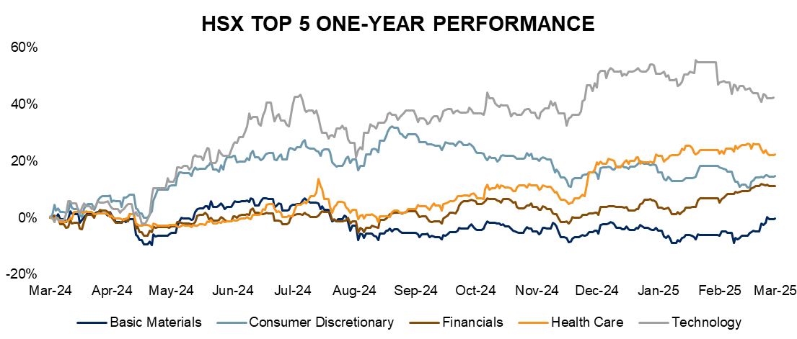

|  |
| --- |
|  |

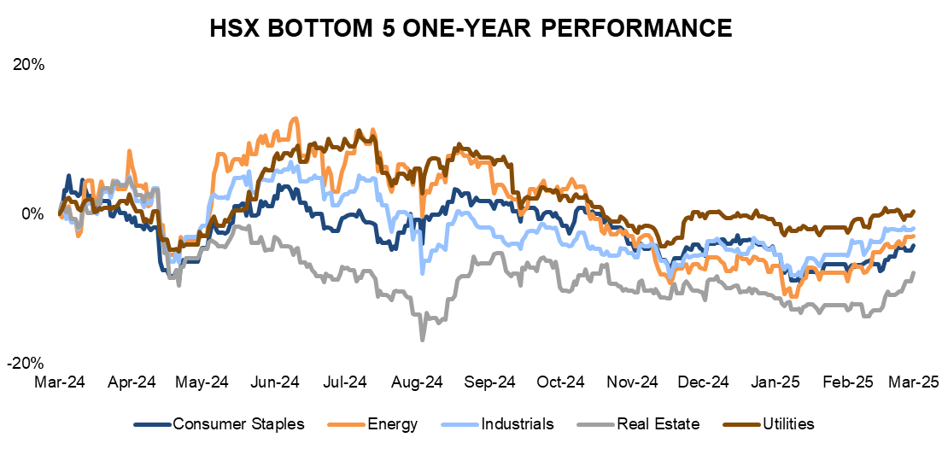



|  |  |  |  |
| --- | --- | --- | --- |
|  | | | |
| Current Price | | VND37,650 | |
| 52Wk High/Low | VND46,500/VND25,040 | | |
| Target Price | | VND42,900 | |
| Previous TP | | VND40,500 | |
| TP vs Consensus | | -0.8% | |
| Upside | | 13.9% | |
| Dividend Yield | | 2.7% | |
| Total stock return | | 16.6% | |
|  | |  | |
| Growth rating | Positive | | |
| Value rating | Positive | | |
| ST Technical Analysis | | [Positive](https://dstock.vndirect.com.vn/tong-quan/SZC/goc-nhin-ky-thuat-popup?defaultType=cipShort) | |
|  | |  | |
| Market Cap | | USD275.4mn | |
| 3m Avg daily value | | USD1.5mn | |
| Avail Foreign Room | | USD47.2mn | |
| Outstanding Shares | | 180.0mn | |
| Fully diluted O/S | | 180.0mn | |
| |  |  |  |  | | --- | --- | --- | --- | |  | SZC | Peers | VNI | | P/E TTM | 23.4x | 18.2x | 15.8x | | P/B Current | 2.3x | 2.6x | 1.7x | | ROA | 3.8% | 5.0% | 1.8% | | ROE | 11.6% | 12.5% | 12.0% |   *data as of 10/1/2024 | | | |
|  | | | |
| Share Price performance | | | |
|  | | | |
|  | | | |
| |  |  |  |  | | --- | --- | --- | --- | |  | | | | | **Share price (%)** | **1M** | **3M** | **YTD** | | SZC | ​0.1 | ​-8.3 | 4.1 | | VNIndex | 0.3 | ​1.4 | 14.0 | | | | |
|  | | | |
| Ownership | | | |
| Sonadezi | | | 47.2% |
| Sonadezi Long Thanh | | | 10.2% |
| Others | | | 42.6% |
| Business Description | | | |  |
| SZC is a member of Sonadezi Corporation (SNZ) - one of the pioneering IP developers in Vietnam. The company was established in 2007 to develop the Chau Duc urban industrial park & golf project with a total area of ​​2,287ha. With leasing area of 1,109ha in Chau Duc IP, SZC accounts for 31.4% of leasable area and 50.3% of the remaining leaseble IP land area in BR-VT. | | | |  |
|  | | | |  |
|  | | | |  |

**Commodity prices**



**Commodity Price**

**Market Value Drivers**

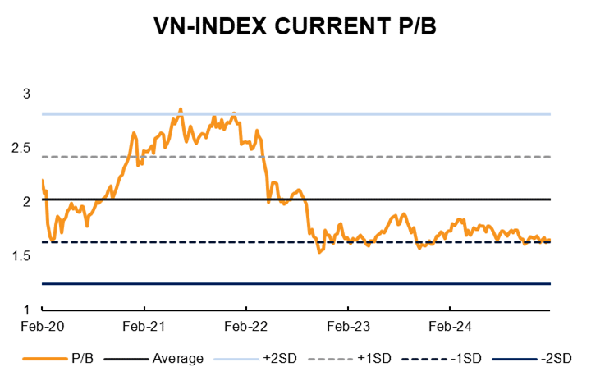

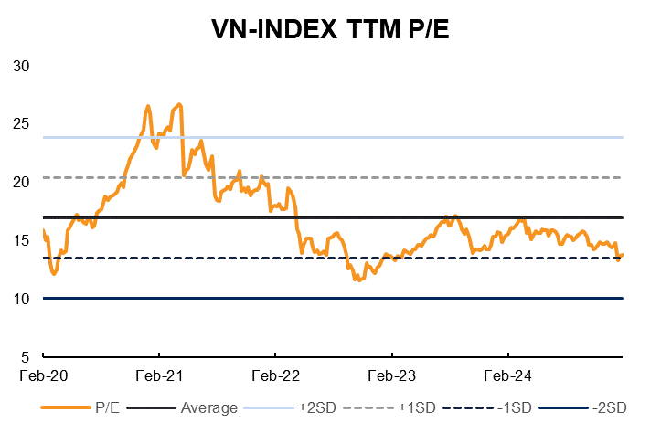

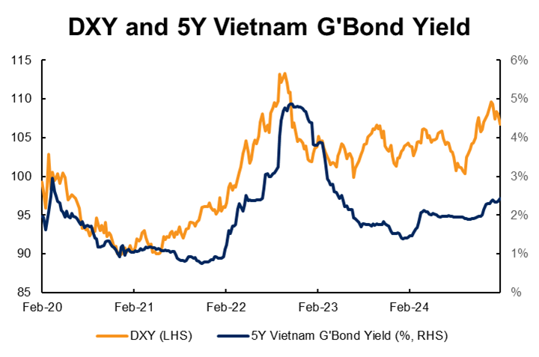

VnDs Research coverage summary

| Ticker | | Market cap (US$m) | 3M ADTV (US$m) | | Foreign Room (US$m) | Closing price  (VND) | Adjusted target price  (VND) | | Total shareholder return (%) | | Dividend yield (%) | TTM P/E | Current P/B | ROE | Recom-mendation |
| --- | --- | --- | --- | --- | --- | --- | --- | --- | --- | --- | --- | --- | --- | --- | --- |
| AVIATION | | |  | |  |  |  | |  | |  |  |  |  |  |
| ACV | | 9,004 | 1.3 | 4,325 | | 105,900 | 136,200 | 28.6% | | 0.0% | | 31.9 | 4.6 | 18% | [HOLD](https://nhanha-public-api.vndirect.com.vn/click/OGE1MjkxZDI5MjY4MjM5MjAxOTI2YjVhNDMwNjQ5N2U=/ZGVlZGMyMWQxZjMyNGY4NWE3NGI2NDFiZDhjNTVhZjg=/deedc21d1f324f85a74b641bd8c55af8-ACV_Update%20report_20241125.pdf/cmVzZWFyY2hAdm5kaXJlY3QuY29tLnZu/NTcwMzM=) |
| VJC | | 2,050 | 5.4 | 374 | | 96,900 | 113,600 | 23.9% | | 0.0% | | 36.8 | 3.1 | 9% | [HOLD](https://nhanha-public-api.vndirect.com.vn/click/OGE1MjkxZDI5MjY4MjM5MjAxOTI2YjVhNDMwNjQ5N2U=/NWU4YzU0ZjM0Y2JjNGRmMzliNWJlMDE1YTVkOTVlZTc=/5e8c54f34cbc4df39b5be015a5d95ee7-VJC_Update_20241225.pdf/cmVzZWFyY2hAdm5kaXJlY3QuY29tLnZu/NTc1Njk=) |
| Simple Avg | | **5,527** | **3.3** | **2,349** | |  |  | **26.3%** | | **0.0%** | | **34.4** | **3.8** | **13%** |  |
| CONGLOMERATE | | |  |  | |  |  |  | |  | |  |  |  |  |  | |
| VIC | 6,280 | | 8.4 | 2,381 | | 42,050 | 45,600 | 11.3% | | 0.0% | | 13.3 | 1.1 | 9% | [HOLD](https://nhanha-public-api.vndirect.com.vn/click/OGE1MjkxZDI5Mjg3MDliZDAxOTI4OTkwZjc0ZDQ5ODY=/YTczNzFiMDI4ZGRmNGU0YmE5NjU1MWJhN2U2ZWIwMzk=/a7371b028ddf4e4ba96551ba7e6eb039-VIC_Update_20250114.pdf/cmVzZWFyY2hAdm5kaXJlY3QuY29tLnZu/NTc3MzE=) |
| CONSTRUCTION | | |  |  | |  |  |  | |  | |  |  |  |  |  | |
| CTD | | 347 | 1.6 | 6 | | 89,000 | 78,900 | -11.3% | | 0.0% | | 23.8 | 1.0 | 4% | [ADD](https://nhanha-public-api.vndirect.com.vn/click/OGE1MjkxZDI5MjY4MjM5MjAxOTI2YjVhNDMwNjQ5N2U=/YTExZTMwY2FlNTkxNDE3MTg4MTk2NWRkNThiMDA0OWU=/a11e30cae5914171881965dd58b0049e-CTD_Update_20241231.pdf/cmVzZWFyY2hAdm5kaXJlY3QuY29tLnZu/NTc2Njk=) |
| HHV | | 214 | 2.0 | 85 | | 12,700 | 13,000 | 2.4% | | 0.0% | | 13.4 | 0.6 | 5% | [HOLD](https://nhanha-public-api.vndirect.com.vn/click/OGE1MjkxZDI5Mjg3MDliZDAxOTI4OTkwZjc0ZDQ5ODY=/YTNhMTZmOGU5OWUzNGNjMWEyMGVhNjEzZWY3NGQxNzg=/a3a16f8e99e34cc1a20ea613ef74d178-HHV_update_20250121.pdf/cmVzZWFyY2hAdm5kaXJlY3QuY29tLnZu/NTc3NDk=) |
| Simple Avg | | **281** | **1.8** | **45** | |  |  | **-4.5%** | | **0.0%** | | **18.6** | **0.8** | **5%** |  |
| CONSUMER | | | |  | |  |  |  | |  | |  |  |  |  |  |  | |
| BAF | | 309 | 2.3 | 103 | | 33,100 | 33,300 | 0.6% | | 0.0% | | 18.9 | 2.7 | 13% | [HOLD](https://nhanha-public-api.vndirect.com.vn/click/OGE1MjkxZDI5MjY4MjM5MjAxOTI2YjVhNDMwNjQ5N2U=/YmFhNTgzZWNkNzI3NDMxOTg1M2YzODE5NGJiNTk0MjI=/baa583ecd7274319853f38194bb59422-BAF_Update_20241219.pdf/cmVzZWFyY2hAdm5kaXJlY3QuY29tLnZu/NTc1MTM=) |
| DGW | | 342 | 3.4 | 94 | | 39,900 | 48,600 | 23.1% | | 1.3% | | 19.6 | 2.9 | 16% | [HOLD](https://www.vndirect.com.vn/cmsupload/beta/DGW_Update_20241112.pdf) |
| IMP | | 285 | #N/A | #N/A | | 47,400 | 51,300 | 8.2% | | 0.0% | | 25.4 | 3.3 | 14% | [HOLD](https://nhanha-public-api.vndirect.com.vn/click/OGE1MjkxZDI5MjY4MjM5MjAxOTI2YjVhNDMwNjQ5N2U=/NjY5MmM0OGRlM2MzNDFkNDkzYTdjN2U0NGE5NjhkNDE=/6692c48de3c341d493a7c7e44a968d41-IMP_Initiation_20250227.pdf/cmVzZWFyY2hAdm5kaXJlY3QuY29tLnZu/NTgxNzg=) |
| MWG | | 3,356 | 12.8 | 112 | | 58,800 | 80,400 | 36.7% | | 0.0% | | 23.1 | 3.1 | 15% | [ADD](https://www.vndirect.com.vn/cmsupload/beta/MWG_Update_20241211.pdf) |
| PNJ | | 1,242 | 5.9 | 0 | | 94,100 | 115,100 | 23.6% | | 1.3% | | 15.3 | 2.8 | 20% | [ADD](https://nhanha-public-api.vndirect.com.vn/click/OGE1MjkxZDI5MjY4MjM5MjAxOTI2YjVhNDMwNjQ5N2U=/YmQ1Nzc2YjU1OGEwNGNhMWIxY2E2MmY1NGI4OGUxYzQ=/bd5776b558a04ca1b1ca62f54b88e1c4-PNJ_Update_20241129.pdf/cmVzZWFyY2hAdm5kaXJlY3QuY29tLnZu/NTcxMTU=) |
| QNS | | 722 | 0.6 | 251 | | 50,300 | 53,000 | 11.2% | | 5.8% | | 7.0 | 1.8 | 27% | [HOLD](https://nhanha-public-api.vndirect.com.vn/click/OGE1MjkxZDI4ZjUxMTJmZTAxOGZlMTY5OTQ3NjQwZWY=/YmQ3MzMxYjZmZTgzNGIzYmEwNWQ0MzhjMjBhNGFiMmQ=/bd7331b6fe834b3ba05d438c20a4ab2d-QNS_Update_20240913.pdf/cmVzZWFyY2hAdm5kaXJlY3QuY29tLnZu/NTU4MTA=) |
| VHC | | 634 | 1.3 | 454 | | 72,300 | 85,000 | 20.1% | | 2.5% | | 12.8 | 1.9 | 14% | [HOLD](https://nhanha-public-api.vndirect.com.vn/click/OGE1MjkxZDI5Mjg3MDliZDAxOTI4OTkwZjc0ZDQ5ODY=/OWJiZDhhZjA5NzQ4NDIyNzg2ZDZjMmU1MmVkZmIwYjc=/9bbd8af09748422786d6c2e52edfb0b7-VHC_Update_20241209.pdf/cmVzZWFyY2hAdm5kaXJlY3QuY29tLnZu/NTgwNDA=) |
| VNM | | 5,159 | 13.5 | 2,641 | | 63,200 | 74,800 | 24.5% | | 6.1% | | 15.7 | 4.1 | 26% | [ADD](https://nhanha-public-api.vndirect.com.vn/click/OGE1MjkxZDI5MjY4MjM5MjAxOTI2YjVhNDMwNjQ5N2U=/MjVlNTdhN2M4N2NjNGM3MTllZDEzMGI4Y2FlOGI0MTg=/25e57a7c87cc4c719ed130b8cae8b418-VNM_Update_20241225.pdf/cmVzZWFyY2hAdm5kaXJlY3QuY29tLnZu/NTc1NzM=) |
| SAB | | 2,590 | 2.3 | 1,114 | | 51,700 | 59,900 | 15.9% | | 0.0% | | 15.4 | 2.8 | 18% | [ADD](https://nhanha-public-api.vndirect.com.vn/click/OGE1MjkxZDI5MjY4MjM5MjAxOTI2YjVhNDMwNjQ5N2U=/MTI0ODIxNWZjNWFiNDA4N2JlZjliMTczNjYxMTA2N2Y=/1248215fc5ab4087bef9b1736611067f-SAB_Initiation_20240926.pdf/cmVzZWFyY2hAdm5kaXJlY3QuY29tLnZu/NTgwNDI=) |
| Simple Avg | | **1,506** | **#N/A** | **#N/A** | |  |  | **18.5%** | | **2.1%** | | **17.2** | **2.8** | **18%** |  |
| FINANCIALS | | |  |  | |  |  |  | |  | |  |  |  |  |  | |
| ACB | | 4,536 | 10.1 | 0 | | 26,000 | 34,100 | 34.4% | | 3.3% | | 6.9 | 1.4 | 22% | [ADD](https://nhanha-public-api.vndirect.com.vn/click/OGE1MjkxZDI5MjY4MjM5MjAxOTI2YjVhNDMwNjQ5N2U=/OWVhYTcxYjhkYjlmNDQ0Yjg0NTg5YjJhMWYzZDJlNmY=/9eaa71b8db9f444b84589b2a1f3d2e6f-ACB_Update_20241211.pdf/cmVzZWFyY2hAdm5kaXJlY3QuY29tLnZu/NTczNDk=) |
| BID | | 11,032 | 4.7 | 1,417 | | 40,950 | 51,100 | 24.8% | | 0.0% | | 11.5 | 2.0 | 19% | [HOLD](https://nhanha-public-api.vndirect.com.vn/click/OGE1MjkxZDI5MjY4MjM5MjAxOTI2YjVhNDMwNjQ5N2U=/NWE3ZjQwZjBkMGVjNDhmNzg1OGJmZTNlNmM2YjI1ODg=/5a7f40f0d0ec48f7858bfe3e6c6b2588-BID_Update_20241211.pdf/cmVzZWFyY2hAdm5kaXJlY3QuY29tLnZu/NTgwNDM=) |
| CTG | | 8,652 | 11.9 | 264 | | 41,250 | 43,500 | 7.5% | | 2.1% | | 8.7 | 1.5 | 18% | [HOLD](https://www.vndirect.com.vn/cmsupload/beta/CTG_Update_20250221.pdf) |
| HDB | | 3,140 | 11.9 | 53 | | 23,000 | 34,900 | 51.7% | | 0.0% | | 6.3 | 1.5 | 26% | [ADD](https://nhanha-public-api.vndirect.com.vn/click/OGE1MjkxZDI5MjY4MjM5MjAxOTI2YjVhNDMwNjQ5N2U=/NTkzNWZlNThmMWIyNDZiYmJhMjBhZTk4ODViY2NhZGU=/5935fe58f1b246bbba20ae9885bccade-HDB_Update_20241206.pdf/cmVzZWFyY2hAdm5kaXJlY3QuY29tLnZu/NTcxODI=) |
| LPB | | 4,189 | 4.2 | 142 | | 35,900 | 33,400 | -7.0% | | 0.0% | | 11.1 | 2.5 | 25% | [HOLD](https://nhanha-public-api.vndirect.com.vn/click/OGE1MjkxZDI5MjY4MjM5MjAxOTI2YjVhNDMwNjQ5N2U=/YmMyMGVjZmMzMDdjNDg5Y2I5M2U1MTU3ZDk2MzFkNzg=/bc20ecfc307c489cb93e5157d9631d78-LPB_Update_20241226.pdf/cmVzZWFyY2hAdm5kaXJlY3QuY29tLnZu/NTc1Nzc=) |
| MBB | | 5,506 | 19.6 | 0 | | 23,100 | 30,000 | 34.1% | | 4.2% | | 6.2 | 1.3 | 22% | [ADD](https://nhanha-public-api.vndirect.com.vn/click/OGE1MjkxZDI5MjY4MjM5MjAxOTI2YjVhNDMwNjQ5N2U=/ZDZjNjhmZmViZWIxNDQ1Yjg5MTRlMWU1NmQ1Y2UwNmQ=/d6c68ffebeb1445b8914e1e56d5ce06d-MBB_UpdateReport_20241226.pdf/cmVzZWFyY2hAdm5kaXJlY3QuY29tLnZu/NTc1NzQ=) |
| OCB | | 1,079 | 1.6 | 20 | | 11,200 | 13,400 | 19.6% | | 0.0% | | 8.7 | 0.9 | 11% | [ADD](https://nhanha-public-api.vndirect.com.vn/click/OGE1MjkxZDI5MjY4MjM5MjAxOTI2YjVhNDMwNjQ5N2U=/YTNiZjFjODEzMzA4NGJkYmI3NjRkNGJhNTdkYzBlNzQ=/a3bf1c8133084bdbb764d4ba57dc0e74-OCB_Initiation_20240917.pdf/cmVzZWFyY2hAdm5kaXJlY3QuY29tLnZu/NTgwNDY=) |
| SSI | | 2,038 | 17.5 | 1,209 | | 26,600 | 31,100 | 16.9% | | 0.0% | | 17.7 | 2.0 | 11% | [HOLD](https://nhanha-public-api.vndirect.com.vn/click/OGE1MjkxZDI5Mjg3MDliZDAxOTI4OTkwZjc0ZDQ5ODY=/YTJhZDY5YjdhZGEzNGQxNjgxMGFiNDRkZjQ0ZTBhNDg=/a2ad69b7ada34d16810ab44df44e0a48-SSI_Update_20241003.pdf/cmVzZWFyY2hAdm5kaXJlY3QuY29tLnZu/NTgwMzk=) |
| STB | | 2,861 | 14.2 | 162 | | 38,850 | 45,700 | 17.6% | | 0.0% | | 7.3 | 1.3 | 20% | [ADD](https://www.vndirect.com.vn/cmsupload/beta/STB_Update_20250221.pdf) |
| TCB | | 7,202 | 16.8 | 42 | | 26,100 | 31,100 | 19.2% | | 0.0% | | 8.5 | 1.3 | 16% | [ADD](https://nhanha-public-api.vndirect.com.vn/click/OGE1MjkxZDI5MjY4MjM5MjAxOTI2YjVhNDMwNjQ5N2U=/MzNjZWIzMTE2MzY1NDViMzk4ZTU0Y2VhMDg1ZTYyMDA=/33ceb311636545b398e54cea085e6200-TCB_Update_20241204.pdf/cmVzZWFyY2hAdm5kaXJlY3QuY29tLnZu/NTcxNDY=) |
| TPB | | 1,672 | 10.8 | 1 | | 16,200 | 21,000 | 29.6% | | 0.0% | | 7.0 | 1.1 | 17% | [ADD](https://nhanha-public-api.vndirect.com.vn/click/OGE1MjkxZDI5MjY4MjM5MjAxOTI2YjVhNDMwNjQ5N2U=/OGJlYzQ3NTA4ZmIzNGRhNjg4NDljZmJkN2M0ZWRmNGI=/8bec47508fb34da68849cfbd7c4edf4b-TPB_Update_20241217.pdf/cmVzZWFyY2hAdm5kaXJlY3QuY29tLnZu/NTc0Nzg=) |
| VCB | | 20,367 | 6.0 | 1,323 | | 93,300 | 109,600 | 17.5% | | 0.0% | | 15.4 | 2.6 | 19% | [ADD](https://nhanha-public-api.vndirect.com.vn/click/OGE1MjkxZDI5MjY4MjM5MjAxOTI2YjVhNDMwNjQ5N2U=/MzgzNDE5ZDk0ZDBlNGI4MjgwMDI5NTlhNTc1NjM4YmM=/383419d94d0e4b828002959a575638bc-VCB_Update_20241122.pdf/cmVzZWFyY2hAdm5kaXJlY3QuY29tLnZu/NTY5OTQ=) |
| VIB | | 2,444 | 6.8 | -230 | | 21,000 | 23,600 | 12.4% | | 0.0% | | 8.8 | 1.5 | 18% | [ADD](https://www.vndirect.com.vn/cmsupload/beta/VIB_Update_20241220.pdf) |
| VPB | | 5,950 | 18.0 | 330 | | 19,200 | 23,500 | 22.4% | | 0.0% | | 9.7 | 1.1 | 11% | [ADD](https://nhanha-public-api.vndirect.com.vn/click/OGE1MjkxZDI5MjY4MjM5MjAxOTI2YjVhNDMwNjQ5N2U=/Yjc3ZjIyYzFiMjBkNGQ1ZWI5MTA2OGFkZmE3OWE0NGY=/b77f22c1b20d4d5eb91068adfa79a44f-VPB_Update_20241209.pdf/cmVzZWFyY2hAdm5kaXJlY3QuY29tLnZu/NTcyNDU=) |
| Simple Avg | | **5,762** | **11.0** | **338** | |  |  | **21.5%** | | **0.7%** | | **9.6** | **1.6** | **18%** |  |
| GARMENT & TEXTIILE | | | |  | |  |  |  | |  | |  |  |  |  |  |  | |
| MSH | | 174 | 0.3 | 60 | | 59,500 | 54,100 | -6.4% | | 3.9% | | 13.2 | 2.3 | 18% | [HOLD](https://nhanha-public-api.vndirect.com.vn/click/OGE1MjkxZDI5MjY4MjM5MjAxOTI2YjVhNDMwNjQ5N2U=/YTE3ZjRiMGI1NmFjNDdmN2E0MTg4MmVhYjAzNTY4MmQ=/a17f4b0b56ac47f7a41882eab035682d-MSH_Update_20241225.pdf/cmVzZWFyY2hAdm5kaXJlY3QuY29tLnZu/NTc1Njg=) |
| TCM | | 162 | 0.3 | 55 | | 40,700 | 55,200 | 35.6% | | 0.0% | | 16.0 | 1.8 | 12% | [HOLD](https://nhanha-public-api.vndirect.com.vn/click/OGE1MjkxZDI5MjY4MjM5MjAxOTI2YjVhNDMwNjQ5N2U=/NDQ2ZTQyYjdhMDFiNGQ4ZjliMjNjMGRkY2MxNjE0ZWI=/446e42b7a01b4d8f9b23c0ddcc1614eb-TCM_Update_20240927.pdf/cmVzZWFyY2hAdm5kaXJlY3QuY29tLnZu/NTc2NzI=) |
| Simple Avg | | **168** | **0.3** | **57** | |  |  | **14.6%** | | **1.9%** | | **14.6** | **2.1** | **15%** |  |
| INDUSTRIALS | | |  |  | |  |  |  | |  | |  |  |  |  |  | |
| BCM | | 3,056 | 2.0 | 882 | | 75,600 | 82,800 | 10.6% | | 1.1% | | 37.2 | 4.0 | 11% | [ADD](https://nhanha-public-api.vndirect.com.vn/click/OGE1MjkxZDI5MjY4MjM5MjAxOTI2YjVhNDMwNjQ5N2U=/OGYxMzhlOTI4YjkyNDQxN2JjNGMzOWIyNjkzNWQ4ZmY=/8f138e928b924417bc4c39b26935d8ff-BCM_Update_20241224.pdf/cmVzZWFyY2hAdm5kaXJlY3QuY29tLnZu/NTc1NjQ=) |
| BMP | | 374 | 1.1 | 57 | | 115,500 | 140,000 | 31.6% | | 10.4% | | 11.1 | 3.3 | 34% | [ADD](https://nhanha-public-api.vndirect.com.vn/click/OGE1MjkxZDI5MjY4MjM5MjAxOTI2YjVhNDMwNjQ5N2U=/NzI3M2I5NTRmYmIxNDdlZjk5YzY5YWFkNDgyNTQ3NzA=/7273b954fbb147ef99c69aad48254770-BMP_Update_20241115.pdf/cmVzZWFyY2hAdm5kaXJlY3QuY29tLnZu/NTY5Mjk=) |
| GMD | | 983 | 2.7 | 5 | | 60,800 | 73,700 | 24.6% | | 3.4% | | 16.4 | 2.0 | 13% | [HOLD](https://nhanha-public-api.vndirect.com.vn/click/OGE1MjkxZDI5Mjg3MDliZDAxOTI4OTkwZjc0ZDQ5ODY=/Y2ViMmNlMzUzM2E2NDk2M2E1NTU0YmMwMWU1MTJiYWM=/ceb2ce3533a64963a5554bc01e512bac-GMD_Update_20241122.pdf/cmVzZWFyY2hAdm5kaXJlY3QuY29tLnZu/NTY5OTI=) |
| HAH | | 247 | 4.8 | 41 | | 52,200 | 55,900 | 9.0% | | 1.9% | | 10.3 | 1.9 | 21% | [ADD](https://nhanha-public-api.vndirect.com.vn/click/OGE1MjkxZDI5MjY4MjM5MjAxOTI2YjVhNDMwNjQ5N2U=/MzFlYThkNWUzOTg5NDVhODhiZjhjNDRiNDZhYjQzYTQ=/31ea8d5e398945a88bf8c44b46ab43a4-HAH_Update_20241113.pdf/cmVzZWFyY2hAdm5kaXJlY3QuY29tLnZu/NTY4OTg=) |
| VSC | | 207 | 2.1 | 95 | | 18,500 | 19,000 | 5.4% | | 2.7% | | 11.2 | 1.1 | 12% | [HOLD](https://nhanha-public-api.vndirect.com.vn/click/OGE1MjkxZDI5MjY4MjM5MjAxOTI2YjVhNDMwNjQ5N2U=/MzlmYmYzMzcwNmIxNGI1MjkzMDg1M2QwODBjZmY5ZWE=/39fbf33706b14b52930853d080cff9ea-VSC_Initiation_20250303.pdf/cmVzZWFyY2hAdm5kaXJlY3QuY29tLnZu/NTgyMTE=) |
| IDC | | 730 | 2.6 | 181 | | 56,600 | 62,700 | 15.2% | | 4.4% | | 9.4 | 3.3 | 38% | [ADD](https://nhanha-public-api.vndirect.com.vn/click/OGE1MjkxZDI5Mjg3MDliZDAxOTI4OTkwZjc0ZDQ5ODY=/MmEwMzQ1ZGJhZWExNGRlZDg5ZTE4ZDI3ZDdmNmI0YWQ=/2a0345dbaea14ded89e18d27d7f6b4ad-IDC_Update_20241206.pdf/cmVzZWFyY2hAdm5kaXJlY3QuY29tLnZu/NTcxNzg=) |
| KBC | | 902 | 0.0 | 0 | | 30,100 | 30,000 | -0.3% | | 0.0% | | 54.2 | 1.2 | 2% | [HOLD](https://nhanha-public-api.vndirect.com.vn/click/OGE1MjkxZDI5MjY4MjM5MjAxOTI2YjVhNDMwNjQ5N2U=/MDBjZTMxOWNiY2M2NGNjZGIwODc4OGQ1NDAwZWFmZGE=/00ce319cbcc64ccdb08788d5400eafda-KBC_Update_20241223.pdf/cmVzZWFyY2hAdm5kaXJlY3QuY29tLnZu/NTc1NDA=) |
| PHR | | 339 | 0.4 | 98 | | 64,000 | 64,300 | 5.2% | | 4.7% | | 20.1 | 2.3 | 13% | [ADD](https://nhanha-public-api.vndirect.com.vn/click/OGE1MjkxZDI5Mjg3MDliZDAxOTI4OTkwZjc0ZDQ5ODY=/NDIxM2JlOTVmMzVkNDc0ZmJjMmRkY2Q1YzBiYTRhZjM=/4213be95f35d474fbc2ddcd5c0ba4af3-PHR_Update_20240918.pdf/cmVzZWFyY2hAdm5kaXJlY3QuY29tLnZu/NTc0ODA=) |
| PTB | | 159 | 0.0 | 0 | | 60,800 | 79,650 | 32.6% | | 1.6% | | 11.0 | 1.4 | 13% | [ADD](https://www.vndirect.com.vn/cmsupload/beta/PTB_Update_20240827.pdf) |
| SCS | | 279 | 0.6 | 20 | | 75,200 | 85,000 | 18.4% | | 5.4% | | 10.3 | 5.3 | 53% | [HOLD](https://nhanha-public-api.vndirect.com.vn/click/OGE1MjkxZDI5MjY4MjM5MjAxOTI2YjVhNDMwNjQ5N2U=/NjY3MTNmMzZmNGQxNDhjZWI5YzlmMGZkMWU3ZTU3MGY=/66713f36f4d148ceb9c9f0fd1e7e570f-SCS_Update_20241023.pdf/cmVzZWFyY2hAdm5kaXJlY3QuY29tLnZu/NTY1MTE=) |
| SZC | | 323 | 1.5 | 45 | | 45,950 | 42,700 | -3.6% | | 3.5% | | 27.0 | 2.7 | 12% | [ADD](https://www.vndirect.com.vn/cmsupload/beta/SZC_Update_20241009.pdf) |
| VTP | | 728 | 2.5 | 169 | | 153,000 | 126,500 | -16.3% | | 1.0% | | 67.5 | 12.5 | 18% | [HOLD](https://nhanha-public-api.vndirect.com.vn/click/OGE1MjkxZDI5Mjg3MDliZDAxOTI4OTkwZjc0ZDQ5ODY=/MTk4NjY1YjkzOTM4NGE4NTg1NzcwMWE3MjUwOTAwNmU=/198665b939384a85857701a72509006e-VTP_Update_20241129.pdf/cmVzZWFyY2hAdm5kaXJlY3QuY29tLnZu/NTcxMTQ=) |
| Simple Avg | | **694** | **1.7** | **133** | |  |  | **11.0%** | | **3.3%** | | **23.8** | **3.4** | **20%** |  |
| MATERIALS | | |  |  | |  |  |  | |  | |  |  |  |  |  | |
| DGC | | 1,681 | 9.2 | 533 | | 113,300 | 143,600 | 30.8% | | 4.0% | | 15.3 | 3.2 | 22% | [HOLD](https://nhanha-public-api.vndirect.com.vn/click/OGE1MjkxZDI4YmE0MWM3OTAxOGMxZTNjNTdhNTVjZWI=/MjY1ZGJiM2MxYjBiNDQ5ODkyMzdhM2ExMmRlM2ViNDg=/265dbb3c1b0b44989237a3a12de3eb48-DGC_Update_20240529.pdf/cmVzZWFyY2hAdm5kaXJlY3QuY29tLnZu/NTQwNDQ=) |
| HPG | | 7,008 | 22.9 | 1,808 | | 28,050 | 30,000 | 7.0% | | 0.0% | | NA | 1.6 | 11% | [HOLD](https://nhanha-public-api.vndirect.com.vn/click/OGE1MjkxZDI5MjY4MjM5MjAxOTI2YjVhNDMwNjQ5N2U=/NWNjNTc1OTlhZDRiNDI1MWI2NGFkZGEzZTJiZTZiYzU=/5cc57599ad4b4251b64adda3e2be6bc5-HPG_update_20241210.pdf/cmVzZWFyY2hAdm5kaXJlY3QuY29tLnZu/NTczMjY=) |
| HSG | | 458 | 9.2 | 193 | | 18,900 | 26,000 | 37.6% | | 0.0% | | NA | 1.1 | 5% | [HOLD](https://nhanha-public-api.vndirect.com.vn/click/OGE1MjkxZDI5MjY4MjM5MjAxOTI2YjVhNDMwNjQ5N2U=/NDJlNzI4YmRmNzEwNDYwYWJiMGEyZWI0YjAxZWFlZDg=/42e728bdf710460abb0a2eb4b01eaed8-HSG_update_20250113.pdf/cmVzZWFyY2hAdm5kaXJlY3QuY29tLnZu/NTc3Mjg=) |
| NKG | | 279 | 4.1 | 90 | | 15,950 | 12,600 | 37.9% | | 0.0% | | NA | 0.9 | 8% | [HOLD](https://nhanha-public-api.vndirect.com.vn/click/OGE1MjkxZDI5Mjg3MDliZDAxOTI4OTkwZjc0ZDQ5ODY=/YzBiNjY0ZmYxYmM4NDMwNzk0YzEyZWEzMTI2ODM3MGU=/c0b664ff1bc8430794c12ea31268370e-NKG__Update_20250114.pdf/cmVzZWFyY2hAdm5kaXJlY3QuY29tLnZu/NTc3MzM=) |
| Simple Avg | | **2,356** | **11.3** | **656** | |  |  | **28.3%** | | **1.0%** | | **15.3** | **1.7** | **12%** |  |
| OIL & GAS | | |  |  | |  |  |  | |  | |  |  |  |  |  | |
| BSR | | 2,495 | 7.3 | 1,380 | | 20,600 | 22,200 | 11.3% | | 3.6% | | N/A | 1.2 | N/A | [HOLD](https://www.vndirect.com.vn/cmsupload/beta/BSR_Update_20250221.pdf) |
| GAS | | 6,277 | 4.0 | 3,146 | | 68,600 | 85,000 | 40.7% | | 4.4% | | 15.6 | 2.7 | 17% | [ADD](https://nhanha-public-api.vndirect.com.vn/click/OGE1MjkxZDI5MjY4MjM5MjAxOTI2YjVhNDMwNjQ5N2U=/MzdjN2Q3MDc0ZmU0NDMxNTkyZjFjZGY5ZTc5NTkzNTM=/37c7d7074fe4431592f1cdf9e7959353-GAS_Update_20241217.pdf/cmVzZWFyY2hAdm5kaXJlY3QuY29tLnZu/NTc0NDk=) |
| OIL | | 545 | 1.3 | 2 | | 13,500 | 14,600 | 9.8% | | 1.7% | | 32.2 | 1.3 | 4% | [ADD](https://nhanha-public-api.vndirect.com.vn/click/OGE1MjkxZDI5MjY4MjM5MjAxOTI2YjVhNDMwNjQ5N2U=/N2JmN2QzNDAwZDVjNDJiZmEyMzUwMmViY2FlZWZmNGI=/7bf7d3400d5c42bfa23502ebcaeeff4b-OIL_Initiation_202401205.pdf/cmVzZWFyY2hAdm5kaXJlY3QuY29tLnZu/NTcxNTE=) |
| PLX | | 2,193 | 3.3 | 51 | | 44,200 | 56,600 | 29.6% | | 1.6% | | 20.4 | 2.2 | 11% | [ADD](https://nhanha-public-api.vndirect.com.vn/click/OGE1MjkxZDI5MjY4MjM5MjAxOTI2YjVhNDMwNjQ5N2U=/NmY1Njc5ZDYyYWVhNGRhNmJjYzU2OTY1NWRlMjBlZGE=/6f5679d62aea4da6bcc569655de20eda-PLX_Update_20250109.pdf/cmVzZWFyY2hAdm5kaXJlY3QuY29tLnZu/NTc3MjM=) |
| PVD | | 534 | 4.1 | 210 | | 24,600 | 30,900 | 25.6% | | 0.0% | | 24.7 | 0.9 | 5% | [HOLD](https://nhanha-public-api.vndirect.com.vn/click/OGE1MjkxZDI5Mjg3MDliZDAxOTI4OTkwZjc0ZDQ5ODY=/MDRhOTE1NzM4ZmUzNDBiNzgyNDY0Mzg4NjhjMmFlZDc=/04a915738fe340b78246438868c2aed7-PVD_Update_20241115.pdf/cmVzZWFyY2hAdm5kaXJlY3QuY29tLnZu/NTY5MjY=) |
| PVS | | 659 | 4 | 204 | | 35,300 | 45,800 | 32.6% | | 2.8% | | 14.3 | 1.3 | 9% | [ADD](https://www.vndirect.com.vn/cmsupload/beta/PVS_Update_20250214.pdf) |
| PVT | | 371 | 2.2 | 143 | | 26,650 | 33,000 | 27.5% | | 3.7% | | 8.7 | 1.2 | 15% | [ADD](https://nhanha-public-api.vndirect.com.vn/click/OGE1MjkxZDI5MjY4MjM5MjAxOTI2YjVhNDMwNjQ5N2U=/MjY1ODQ0ZDQ1MWUzNDI5ODg4NWE4YWU0ZDhkODJlYWU=/265844d451e34298885a8ae4d8d82eae-PVT_Update_20241213.pdf/cmVzZWFyY2hAdm5kaXJlY3QuY29tLnZu/NTc0MDI=) |
| Simple Avg | | **1,868** | **3.8** | **734** | |  |  | **25.3%** | | **2.6%** | | **19.3** | **1.5** | **10%** |  |
| PETROCHEMICALS | | |  |  | |  |  |  | |  | |  |  |  |  |  | |
| DPM | | 563 | 4.0 | 219 | | 36,850 | 37,300 | 6.6% | | 5.4% | | 24.3 | 1.3 | 5% | [HOLD](https://nhanha-public-api.vndirect.com.vn/click/OGE1MjkxZDI5MjY4MjM5MjAxOTI2YjVhNDMwNjQ5N2U=/Yjc3ZjIyYzFiMjBkNGQ1ZWI5MTA2OGFkZmE3OWE0NGY=/b77f22c1b20d4d5eb91068adfa79a44f-VPB_Update_20241209.pdf/cmVzZWFyY2hAdm5kaXJlY3QuY29tLnZu/NTcyNDU=) |
| DCM | | 734 | 5.9 | 326 | | 35,500 | 37,300 | 5.1% | | 0.0% | | 14.8 | 1.9 | 13% | [ADD](https://nhanha-public-api.vndirect.com.vn/click/OGE1MjkxZDI5Mjg3MDliZDAxOTI4OTkwZjc0ZDQ5ODY=/YjY3OGViZTkzNGQ2NGIxMzg1NGI3MDgyMjAwMzVkZmQ=/b678ebe934d64b13854b708220035dfd-DCM_Update_20241129.pdf/cmVzZWFyY2hAdm5kaXJlY3QuY29tLnZu/NTgwNTA=) |
| PLC | | 83 | 0.2 | 37 | | 26,200 | 30,800 | 25.5% | | 7.9% | | 49.0 | 1.7 | 3% | [ADD](https://nhanha-public-api.vndirect.com.vn/click/OGE1MjkxZDI5MjY4MjM5MjAxOTI2YjVhNDMwNjQ5N2U=/YzVmMTU4ZjcwNjYyNGJhMGI5ZmY4OWM5ZmVhYjg1MDI=/c5f158f706624ba0b9ff89c9feab8502-PLC_Update_20250220.pdf/cmVzZWFyY2hAdm5kaXJlY3QuY29tLnZu/NTgwODE=) |
| Simple Avg | | **460** | **3.3** | **194** | |  |  | **12.4%** | | **4.4%** | | **29.4** | **1.6** | **7%** |  |
| POWER | | |  |  | |  |  |  | |  | |  |  |  |  |  | |
| NT2 | | 233 | 0.4 | 79 | | 20,750 | 27,100 | 40.6% | | 10.0% | | 82.5 | 1.4 | 2% | [HOLD](https://nhanha-public-api.vndirect.com.vn/click/OGE0ODlmZDA3ODBmMjMzZDAxNzgwZmU1YWI2ZTAwMDU=/ZGZlODBiYmIwZTJiNDJmM2JjZTcyYzdiY2M4Y2ZjYTI=/dfe80bbb0e2b42f3bce72c7bcc8cfca2-NT2_Update_20240308.pdf/cmVzZWFyY2hAdm5kaXJlY3QuY29tLnZu/NTI5NDE=) |
| POW | | 1,125 | 4.3 | 529 | | 12,300 | 14,900 | 21.1% | | 0.0% | | 23.0 | 0.9 | 4% | [ADD](https://nhanha-public-api.vndirect.com.vn/click/OGE1MjkxZDI5Mjg3MDliZDAxOTI4OTkwZjc0ZDQ5ODY=/MmRjMDIxZjdkN2E5NDgxYThkMTdiYzcxOTg1ZjkxOTM=/2dc021f7d7a9481a8d17bc71985f9193-POW_Update_20241213.pdf/cmVzZWFyY2hAdm5kaXJlY3QuY29tLnZu/NTgwNDk=) |
| Simple Avg | | **679** | **2.3** | **304** | |  |  | **30.9%** | | **5.0%** | | **52.8** | **1.2** | **3%** |  |
| POWER & PROPERTY | | | |  | |  |  |  | |  | |  |  |  |  |  |  | |
| HDG | | 369 | 4.9 | 129 | | 28,100 | 34,100 | 23.1% | | 1.8% | | 16.4 | 1.5 | 9% | [ADD](https://nhanha-public-api.vndirect.com.vn/click/OGE1MjkxZDI5MjY4MjM5MjAxOTI2YjVhNDMwNjQ5N2U=/NDMxYjAzZGNkZjA3NDA1MmE5Y2FmY2JiY2FiZTI0NTY=/431b03dcdf074052a9cafcbbcabe2456-HDG_Update_20241016.pdf/cmVzZWFyY2hAdm5kaXJlY3QuY29tLnZu/NTY0NDc=) |
| PC1 | | 335 | 3.2 | 123 | | 24,000 | 35,300 | 47.1% | | 0.0% | | 20.7 | 1.6 | 8% | [ADD](https://nhanha-public-api.vndirect.com.vn/click/OGE1MjkxZDI5MjY4MjM5MjAxOTI2YjVhNDMwNjQ5N2U=/YmY1MGIzNmU4ZDk5NDJmYzgwY2I2Y2MyZWVmOTc3ZGM=/bf50b36e8d9942fc80cb6cc2eef977dc-PC1_Update_20250116.pdf/cmVzZWFyY2hAdm5kaXJlY3QuY29tLnZu/NTc3MzY=) |
| REE | | 1,336 | 2.2 | 0 | | 72,600 | 72,900 | 1.8% | | 1.4% | | 17.1 | 1.8 | 11% | [ADD](https://nhanha-public-api.vndirect.com.vn/click/OGE1MjkxZDI5MjY4MjM5MjAxOTI2YjVhNDMwNjQ5N2U=/NGNlNzkyMmIzZTBjNDA1ODhlZTUwZDU4ZTRkYzI3NmI=/4ce7922b3e0c40588ee50d58e4dc276b-REE_Update_20241127.pdf/cmVzZWFyY2hAdm5kaXJlY3QuY29tLnZu/NTcwNjE=) |
| Simple Avg | | **680** | **3.4** | **84** | |  |  | **24.0%** | | **1.0%** | | **18.1** | **1.6** | **9%** |  |
| PROPERTY | | |  |  | |  |  |  | |  | |  |  |  |  |  | |
| DXG | | 551 | 6.8 | 136 | | 16,200 | 17,500 | 8.0% | | 0.0% | | 48.0 | 1.2 | 3% | [HOLD](https://nhanha-public-api.vndirect.com.vn/click/OGE1MjkxZDI5MjY4MjM5MjAxOTI2YjVhNDMwNjQ5N2U=/NjQxOTJmMmE2ZWZlNDIyNzk4OTJiNWFjMTA0MjVjMTI=/64192f2a6efe42279892b5ac10425c12-DXG_Update_20250110.pdf/cmVzZWFyY2hAdm5kaXJlY3QuY29tLnZu/NTc3MjQ=) |
| KDH | | 1,327 | 4.1 | 163 | | 33,600 | 41,300 | 36.3% | | 0.0% | | 42.6 | 2.0 | 5% | [ADD](https://nhanha-public-api.vndirect.com.vn/click/OGE1MjkxZDI5MjY4MjM5MjAxOTI2YjVhNDMwNjQ5N2U=/YjRjNDExYzFhYThhNGUzM2FlNWYyZDM4YTNlMGQ5ODg=/b4c411c1aa8a4e33ae5f2d38a3e0d988-KDH_Update_20241218.pdf/cmVzZWFyY2hAdm5kaXJlY3QuY29tLnZu/NTc0NTU=) |
| NLG | | 518 | 2.7 | 1 | | 34,450 | 46,200 | 36.4% | | 2.3% | | 27.1 | 1.4 | 5% | [ADD](https://nhanha-public-api.vndirect.com.vn/click/OGE1MjkxZDI5MjY4MjM5MjAxOTI2YjVhNDMwNjQ5N2U=/ODYyZDYxYzAxYWJjNDFmMWI0MjZkN2RlZTljOTMyNzg=/862d61c01abc41f1b426d7dee9c93278-NLG_Update_20241211.pdf/cmVzZWFyY2hAdm5kaXJlY3QuY29tLnZu/NTczMzQ=) |
| VHM | | 6,826 | 20.7 | 2,777 | | 42,550 | 48,800 | 23.9% | | 0.0% | | 5.9 | 0.9 | 16% | [ADD](https://nhanha-public-api.vndirect.com.vn/click/OGE1MjkxZDI5MjY4MjM5MjAxOTI2YjVhNDMwNjQ5N2U=/MWNjM2ZmYzYxYjc4NDQ0ODkyN2NjNWIwNmFjYjYyYzI=/1cc3ffc61b784448927cc5b06acb62c2-VHM_Update_20241218.pdf/cmVzZWFyY2hAdm5kaXJlY3QuY29tLnZu/NTc0NTI=) |
| VRE | | 1,571 | 7.1 | 465 | | 17,700 | 20,200 | 14.1% | | 0.0% | | 9.8 | 1.0 | 10% | [ADD](https://nhanha-public-api.vndirect.com.vn/click/OGE1MjkxZDI5MjY4MjM5MjAxOTI2YjVhNDMwNjQ5N2U=/ZDgyN2Y4ODdmZmZlNGM5NGIxMzA4MjYxMTY5YzhjMjY=/d827f887fffe4c94b1308261169c8c26-VRE_Update_20241128.pdf/cmVzZWFyY2hAdm5kaXJlY3QuY29tLnZu/NTcwNjQ=) |
| DXS | | 165 | 0.2 | 40 | | 7,300 | 7,000 | -4.1% | | 0.0% | | N/A | 0.7 | 2% | [HOLD](https://nhanha-public-api.vndirect.com.vn/click/OGE1MjkxZDI5MjY4MjM5MjAxOTI2YjVhNDMwNjQ5N2U=/NGNkNjdhNGE5MWY3NGVmZWI2ZWE4ODAyOTA1YjliOTQ=/4cd67a4a91f74efeb6ea8802905b9b94-DXS_Update_20250212.pdf/cmVzZWFyY2hAdm5kaXJlY3QuY29tLnZu/NTc5OTg=) |
| Simple Avg | | **2,159** | **8.3** | **708** | |  |  | **23.7%** | | **0.5%** | | **26.7** | **1.3** | **8%** |  |
| TECHNOLOGY | |  |  |  | |  |  |  | |  | |  |  |  |  |
| FPT | 8,073 | | 23.1 | 195 | | 140,500 | 196,600 | 41.4% | | 1.5% | | 26.2 | 6.9 | 29% | [ADD](https://nhanha-public-api.vndirect.com.vn/click/OGE1MjkxZDI5Mjg3MDliZDAxOTI4OTkwZjc0ZDQ5ODY=/MTVkZmFhZDkwZWQ2NGExZTkyZjUzMjkzYzA3ZTFlODc=/15dfaad90ed64a1e92f53293c07e1e87-FPT_Update_20241209.pdf/cmVzZWFyY2hAdm5kaXJlY3QuY29tLnZu/NTgwNDg=) |

|  |  |  |  |  |  |  |  |  |  |  |
| --- | --- | --- | --- | --- | --- | --- | --- | --- | --- | --- |
|  |  |  |  |  |  |  |  |  |  |  |
|  |  |  |  |  |  |  |  |  |  |  |
|  |  |  |  |  |  |  |  |  |  |  |



DISCLAIMER

This report has been prepared by VNDIRECT or one of its affiliates for distribution in Vietnam and overseas. The information herein is believed by VNDIRECT to be reliable and is based on public sources believed to be reliable. With exception of information about VNDIRECT, VNDIRECT makes no representation about the accuracy of such information.

Options, estimates and projection expressed in this report represent the current views of the author at the date of publication only. They do not necessarily reflect the opinions of VNDIRECT and are subject to change without notice. VNDIRECT has no obligation to update, amend or in any way modify this report or otherwise notify a reader thereof in the event that any of the subject matter or opinion, projection or estimate contained within it changes or becomes inaccurate.

The information herein was obtained from various sources and we do not guarantee its accuracy or completeness. Prices and availability of financial instruments are also subject to change without notice.

This published research may be considered by VNDIRECT when buying or selling proprietary positions or positions held by funds under its management. VNDIRECT may trade for its own account as a result of short-term trading suggestions from analysts and may also engage in securities transactions in a manner inconsistent with this report and opinions expressed therein.

Neither the information nor any opinion expressed in this report constitutes an offers, nor an invitation to make an offer, to buy or sell any securities or any option, futures or other derivative instruments in any jurisdiction. Nor should it be construed as an advertisement for any financial instruments.

Officers of VNDIRECT may have a financial interest in securities mentioned in this report or in related instruments. This research report is prepared for general circulation for general information only. It does no have regard to the specific investment objectives, financial situation or particular needs of any person who may receive or read this report.

Investors should note that the prices of securities fluctuate and may rise and fall. Past performance, if any, is no guide to the future. The financial instruments discussed in this report may not be suitable for all investors. Investors must make their own financial decisions based on their independent financial advisors as they believe necessary and based on their particular financial situation and investment objectives.

This report may not be copied, reproduced, published or redistributed by any person for any purpose without the express permission of VNDIRECT in writing. Please cite sources when quoting.

|  |  |  |
| --- | --- | --- |
| **ADDRESS** | | |
| **Headquarter**  1 Nguyen Thuong Hien Str  Hai Ba Trung Dist, Hanoi  T: +84 24 3972 4568  F: +84 24 3972 4568 | **HCMC Office**  The 90th Pasteur Building  90 Pasteur Str, Dist 1, HCMC  T: +84 28 7300 0688  F: +84 28 3914 6924 | **Da Nang Office**  57 Duy Tan Str,  Hai Chau, Da Nang City  T: +84 511 382 1111 |
| **Vinh - Nghe An Office**  122 Hermann Gmeiner str,  Vinh City, Nghe An  T: +84 23 8730 2886  F: NA | **Can Tho Office**  3rd floor STS Building, 11B Hoa Binh  Ninh Kieu City, Can Tho  T: +84 710 3766 959  F: NA | **Quang Ninh Office**  Viet Han Apartment, Hong Gai  Ha Long City, Quang Ninh  T: +84 98 8619 695  F: NA |
| **Thanh Hoa Office**  2nd floor 11 Hac Thanh str  Thanh Hoa City, Thanh Hoa  T: +84 90 3255 202  F: NA | **Binh Duong Office**  18th floor Becamex Tower  Thu Dau Mot City, Binh Duong  T: +84 27 4222 2659  F: +84 27 4222 2660 | **Nam Dinh Office**  5 Nguyen Du str,  Nam Dinh City, Nam Dinh  T: +84 22 8352 8819  F: NA |